Gitlab sample project

I created the project yml file and write sample project code that can help to make a pipeline  
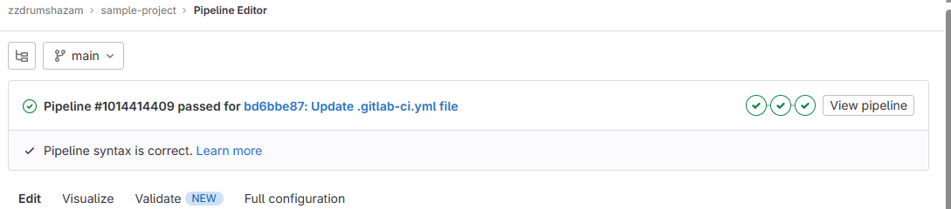  
these are the pipelines  
it passed the test too   
